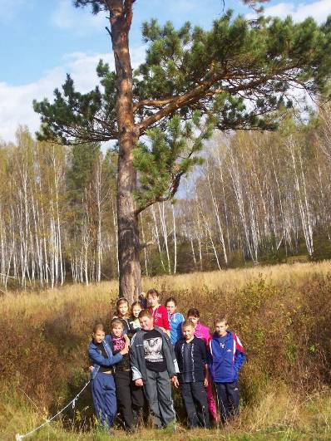

Hello!
We are from Russia-Siberia. We are students of the 7th grade.
We live in the country and we like to go to the forest. We are friendly, talented and always full of ideas. It is our fairy-tale.

TWINS
Once upon a time there lived a princess Liza and her husband prince Ivan.
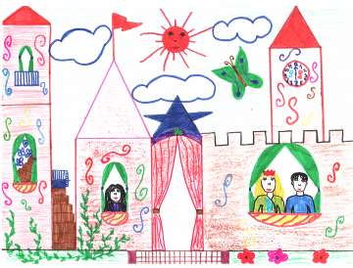

They had a very big castle on the sea shore.
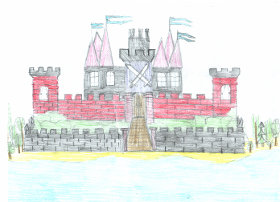

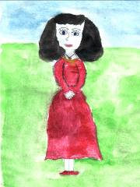
Liza’s sister Marina lived with them

They were twins. But Liza’s hair was white and Marina’s-black. And Marina was a very kind girl, she helped all people and everybody liked her.
But Lisa was a very scandal girl. She was often angry with her husband and sister.

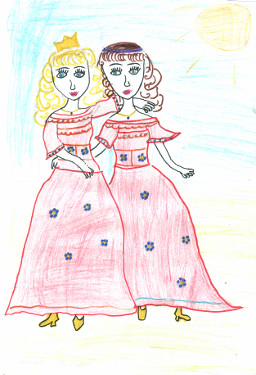

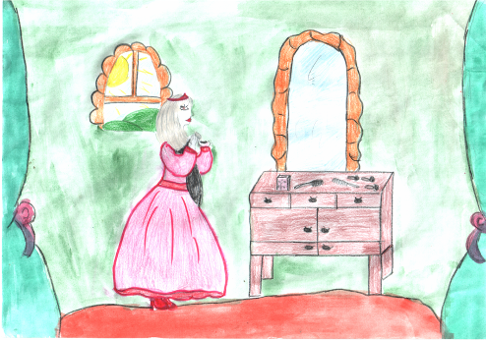
One day Marina changed the color of her hair,.because she didn’t like it. And she had also white hair.

Lisa saw it and she got very angry. She cried and cried and cried and then in anger she went to the forest. She ran ,ran and ran when saw that she had lost her way.
She sat under the tree and began to cry.
“Hhm,hhm! Ha-Ha-Ha!” It was an evil gnome.
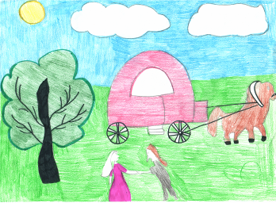
He caught Liza and she fainted. When she opened her eyes she found herself in the castle of the dragon.

Her sister Marina was in panic. Her husband looked for her everywhere.
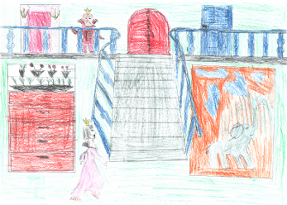
But they couldn’t find the princess.

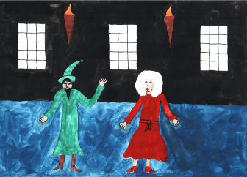

And poor Liza was in a prison.
In the evening an awful gnome came to her and said

“My Lord is Great Dragon. He wants you to be his wife. So, Marina , prepare for your wedding”
“But I’m not Marina. I’m-Liza and I’ve got a husband”
“ If Dragon know it he will kill you and your husband. Then he will marry Marina and become a tsar. If I were you I wouldn’t tell him the truth”
The gnome was afraid the Dragon’s anger because of his mistake.

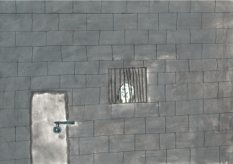

Lisa pretended she was Marina and every day tried to escape from the prison. She had no friends there only a small mouse,called Frosya,
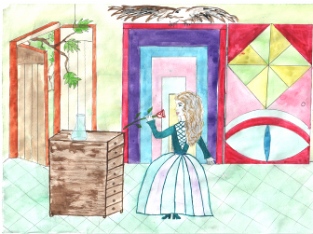
Liza saved her from the cat, gave her cheese and sausage and told about her problems,

It was the day before wedding. Lisa cried “If only I could see Ivan and Marina again. I would never be scandal again. I would always be kind helpful for all people’
Frosya appeared near the chair “ Don’t cry, Lisa! I’ll help you! Take a rose from the vase and follow me!”

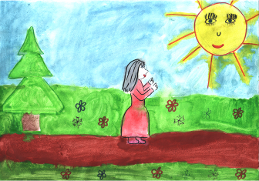

.

It was a magic rose. Liza held it in her hand and nobody could see her.
She became invisible.
Lisa successfully left the castle. Frosya showed her the way to her palace,
Ivan and Marina were really happy when they saw Liza. And Frosya lived with them. Lisa remembered her promise to be always good and she never offended anybody.





